**What is Polkadot (DOT) ?**

Polkadot (DOT) is one of the largest cryptocurrencies on the market and currently ranks 14th by market capitalization.

Polkadot is a blockchain protocol that makes it possible to connect and communicate with different blockchains.

Polkadot thus solves a major problem, since the blockchains are not linked to each other.



=

In practice, there are many projects, cryptocurrencies and thus also blockchains, which are all individually optimized for their use case but have not been programmed to connect with each other.

The individualization of the projects also makes sense, since each individual blockchain can only record a certain number of transactions per hour

However, if the number of transactions becomes too high, bottlenecks arise and there are longer waiting times and increasing transaction fees.

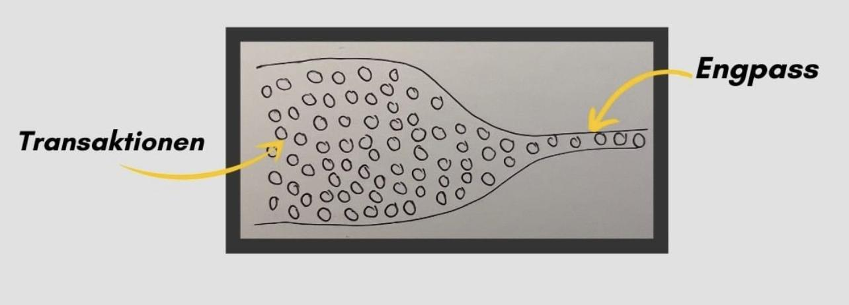

Approach, goal and how it works Polkadot :

You need a system that allows different blockchains to work together with their specific purposes.



The individual blockchains then no longer stand on their own, but are linked to one another and can communicate with one another.

The whole thing should then run as securely and efficiently as possible and be scalable.

Polkadot offers exactly this system.

It connects the individual blockchains and creates a decentralized network

All possible data can then be exchanged between the blockchains via Polkadot for example account balances or tokens. With the linking of the data, so-called DeFi apps can then also be programmed and used.

Overview Polkadot

| Symbol | DOT |
| --- | --- |
| Konsens Algorithmus | Proof of STake |
| Founder | Gavin Wood (Mitgründer von Ethereum), Robert Habermeier, Peter Czaban |
| Publication | 2017 |
| Maximum Supply | 10 Mio (Aug 2020) |
| Market Capitalisation | €15,197,827,657. |
| All Time High (8.12.2020) | $366.84 |
| Use Case | Infrastructure, Smart Contracts, DApps |